***Elevated TA conditions influence juvenile oyster growth when combined with a lower salinity***

1,2Saley, Alisha M., 2Kimball, Zoe & 1,2Brian Gaylord

1 Bodega Marine Laboratory, University of California Davis

2 Dept. of Ecology and Evolution, University of California at Davis

***Abstract—***

Response trajectory—do effects change over time, bigger/small and in what direction

Reasonable expectations; which one plays out

***Introduction—*** Coastal estuaries exhibit variability in the seawater carbonate system, with implications for calcifying inhabitants. For example, biochemical processing and river inflows can cause gradients of total alkalinity (TA) over small distances (cite). Estuarine TA conditions are temporally complex, where conditions can change abruptly and persist for weeks to months, requiring sessile calcifiers to new conform to new conditions. Given the multi-faceted extent to which external seawater conditions dictate performance for marine calcifiers, investigating how responses to such variation in TA change through time, deserves specific attention.

Substantial effort has documented how calcifier growth can be disrupted by perturbations to the carbonate system. Some have emphasized the temporal nature of perturbed conditions, both within and across life stages, finding that the nature of exposure (statis vs fluctuating) and the life-stage at exposure (X vs X) can influence future growth performance (cite). A gap remains in our understanding of the degree to which responses may vary, between the initial period following exposure and a latent period, after an individual has experienced the new seawater condition for multiple weeks’ time. Following exposure to new conditions, many calcifiers conform their internal fluids to match external conditions, creating physiological trade-offs between investing energy into maintenance versus growth (shell or tissue). As such, overall patterns of net growth to variable conditions could look similar in individuals that, in fact, exhibited very different growth patterns through time.

Exploring how growth rate responds to altered TA conditions through time is a natural complement to prior work. Others have documented disrupted growth in many calcifiers following abrupt shifts to carbonate system conditions (cite), with substantial attention devoted to understanding the consequences of human-derived ocean acidification (for review see Gazeau et al 2013). Drastic drops in salinity also have consequences on growth (cite), though, diluted TA may have interacted with lower salinity. Observed declines in growth can signify metabolic downregulation (cite) and an unmet increase in energetic demand (cite), which could result in trade-offs between shell and tissue growth (cite). What remains unexplored is how growth may change over time in response to variable TA conditions, specifically in calcifiers known to experience, and tolerate, a wide range of conditions.

In estuaries, oysters have significant economic and ecological value to coastline habitats and communities. As oysters naturally form reefs, they provide habitat for other estuarine species (cite) and can protect shoreline from X (cite). Commercially, they are be grown and harvested for consumption, economically contributing to a growing human shellfish diet (cite). As such, emphasis is often placed on both growth of the shell and of tissue mass. Juvenile growth in particular can be sensitive to abrupt changes in conditions (cite), which, could result in trade-offs between shell or tissue growth (cite).

Here we explore the how influence of TA condition on surface area shell growth can vary between initial and latent periods in the juvenile Eastern oyster (*Crassostrea virginica*), depending on the salinity. We quantified incremental surface area growth of oyster valves across two time periods as a function of TA condition and accounted for the effect of oyster size at the start of the period, separately, in ambient and low salinity treatments. We did not observe differences in surface area growth initially among TA treatments, in either salinity. Growth rate patterns changed slightly in the latent period, where oysters in low salinity treatments combined with elevated TA exhibited higher growth rates than those in TA conditions simulating dilution with DI. Additionally, growth rates were lower in the latent period than the initial period, in all TA conditions. Given the known shifts between periods of energy assimilation and storage, shell growth, or tissue growth in oysters, we also compared average oyster shell thickness (shell mass per area) and condition index (tissue mass per shell mass) as a function of TA conditions. In ambient and salinity treatments, we did not see any trade-offs to tissue mass or shell thickness, as neither oyster shell thickness nor condition index varied as a function of TA condition. Examinations such as these lend insights into oysters may respond to abrupt changes in estuarine conditions through time.

***Methods—***

**Study species—** The Eastern oyster, *Crassostrea virginica*, is native to estuaries of eastern North America, from the Gulf of St. Lawrence to the Gulf of Mexico. (cite) Due in part to its wide salinity and thermal tolerance, this species is also grown commercially elsewhere, including X (cite), For our experiments, we sourced juvenile oysters from a local aquaculture farm in Tomales Bay, California, USA (Hog Island Oyster Company; coordinates). On 22 July 2022, we transported oysters in cool seawater from Tomales Bay to Bodega Marine Laboratory (BML; Bodega Bay, California, 60 min transit time), and placed them immediately into flow-through, continuously bubbled seawater drawn from the adjacent ocean. We fed the oysters with slow-release mixed algal diet (X% of their wet mass; [**provide supplier**]) once every two days, throughout a 30-d lab acclimation period. At the end of the acclimation period, we glued the oysters (left valve) to plastic plates using X marine epoxy (n = 49 per plate, n = 12 plates) following X et al (cite year). We then returned the plates with attached oysters to the acclimation tanks, and three days hence began a pair of complementary, 36-d growth experiments (Fig. 1).

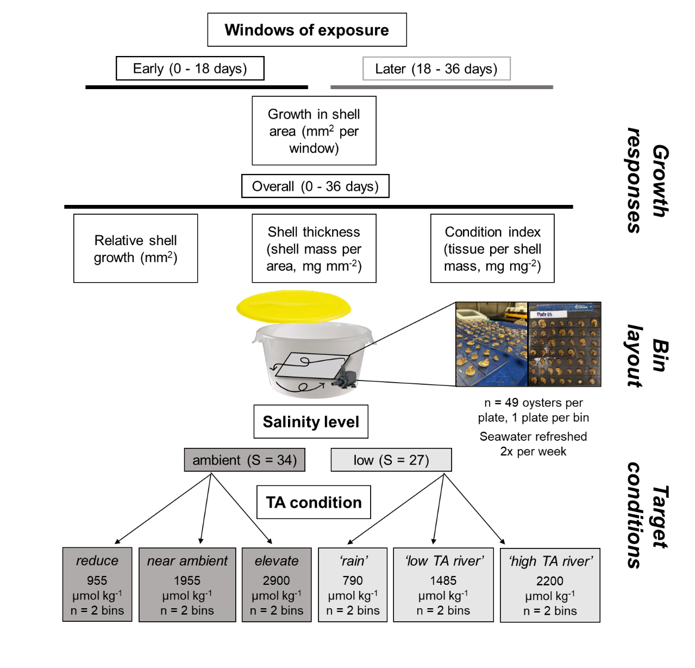

Fig. 1. Schematic of A) experimental culture conditions and B) measured growth responses as a function of exposure window. We conducted growth experiments of C virginica oysters across 6 TA conditions within 2 salinities. Oysters on plates were positioned horizontally, facing toward continuous seawater circulation in the bins. We measured *growth in shell area* in an early (0-18 days) and later (18-36 days) window. We measured *relative shell growth* (per 36 days), shell thickness (mg mm-2), and the condition index (mg mg-2) only at the end of the experiment.

**A**

**B**

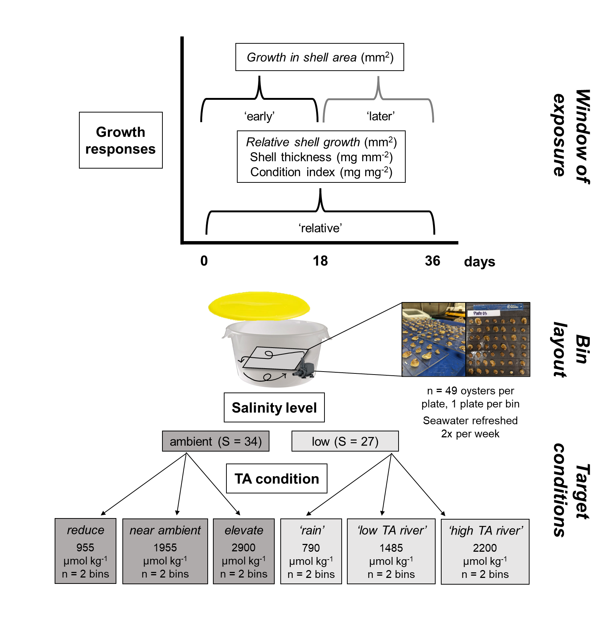

Fig. 1. Schematic of A) experimental culture conditions and B) measured growth responses as a function of exposure window. We measured growth in juvenile C. virginica oyster shell area in an early (0-18 days) and later (18-36 days) window. We measured relative shell growth (per 36 days), shell thickness (mg mm-2), and the condition index (mg mg-2) only at the end of the experiment.

**A**

**B**

**Experiment 1—** In a first study component, we asked whether TA affects oyster shell growth in the simplest possible way, focusing on altered alkalinity in seawater of ambient salinity. We established two replicate cultures at ambient salinity (S=34) for each of three TA levels: 955, 1955, and 2900 µmol kg-1. The experimental design therefore encompassed 49 oysters x 2 static cultures x 3 alkalinity levels = 294 individuals, all at S = 34 (Fig. 1).

**Experiment 2—** In a second study component, we refined our perspective in recognition that oysters live preferentially in estuaries. Estuaries frequently experience decreased salinity, and declines in salinity can be accompanied by a range of TA levels. For instance, in estuaries that receive streams from watersheds of carbonate geology, salinity depressions can be associated with surprisingly high TA. In other cases, freshwater inputs may tie mostly to rain, which has negligible TA, leading to oysters experiencing low S joined with low TA. Given the range in possible TA conditions that can accompany low S, we used two replicate cultures at S=27 for each of three TA levels: 790, 1485, and 2200 µmol kg-1. The design for this second experiment thus contained 49 oysters x 2 static cultures x 3 alkalinity levels = 294 individuals, all at S = 27 (Fig. 1).

**Oyster growth—** During each of the two experiments, we tracked changes in shell surface area through time. Because a primary goal was to distinguish early from later growth patterns in oysters, we took photos of shell area on day 0, day 18, and day 36. The aim was to compare responses during the early time window (days 0-18) to those during the later time window (days 19-36). We analyzed the photos using ImageJ software (v.X) to determine projected surface area of each oyster’s top valve, ensuring a scale bar was visible in each image. We computed both the *growth in shell area* (difference in shell area between start and end dates) within early and later windows, and *relative shell growth* (increase in shell area divided by initial area) to look at how patterns manifested overall. We also measured condition index at the end of each of the experiments, which we quantified as dry tissue mass per dry shell mass, after separating the tissue from the shells and drying each at 60°C for 48 hr. We then divided shell mass by shell area to develop a rough metric of shell thickness.

**Culture conditions—** Each static culture during both experiments included an aquarium pump to ensure adequate water motion. The continuous stirring allowed gas exchange at the water’s surface to keep oxygen levels at >80% saturation . The only exceptions were two cultures that dropped to X% on one occasion each due to pump failure. The resulting episodes of decreased oxygen lasted less than X hr. Oysters were fed daily [with X] during each experiments, and were held in the dark to minimize the influence of shadows on activity (cite). Complete water changes were done every three days, and the sides of the culture vessels, and pumps, cords, and tubing were cleaned of any fouling organisms and debris. The experimental cultures had lids but were not tightly sealed due to a gap created by the pump power cord, which resulted in minor chemical drift between water changes (Fig. 2). Despite this drift, chemical conditions across treatments remained distinct and differed statistically. Any mortality of oysters (always <X%) was recorded at the same time as water changes, and shells of deceased oysters were promptly removed from the cultures and discarded.

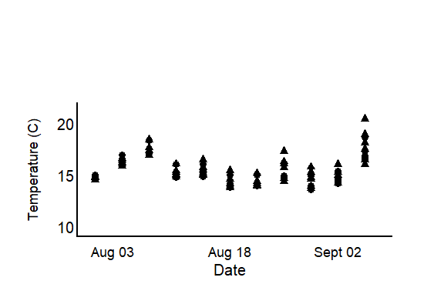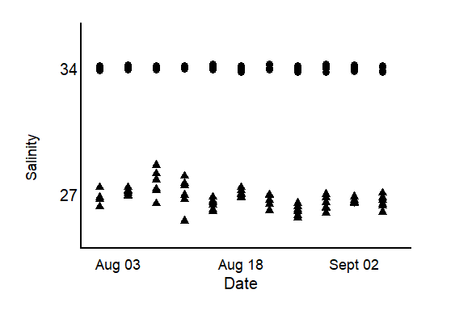

Fig. 2. Results of treatment monitoring of seawater throughout the experiment exhibit marginal variability in A) total alkalinity (unit), B) salinity, and C) temperature (unit) conditions throughout the experiment, though, treatments remained distinct. Measurements for temperature and salinity were taken prior to, and after, water changes using a multiparameter sonde. We collected seawater at the same time to later analyze for total alkalinity. A) Total alkalinity targets were duplicated across 6 ranges that spanned far below to well above ambient seawater conditions (~2250umol kg).. Dashed lines indicate the average TA condition in each bin (legend).B) Very little variability in ambient salinity conditions with low salinity conditions ranging from X to X, with an average of X +_ SE. C, denoted by marker shape (triangle S=27, circle S = 34). In all bins seawater temperature fluctuated between X and X (average X + SE C).

**C**

**B**

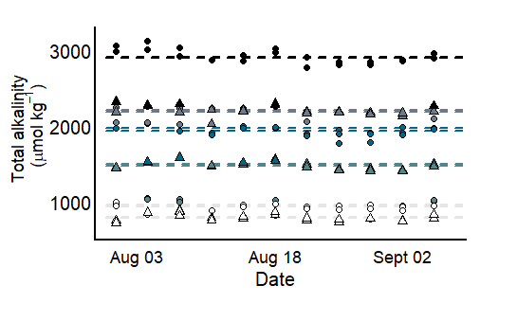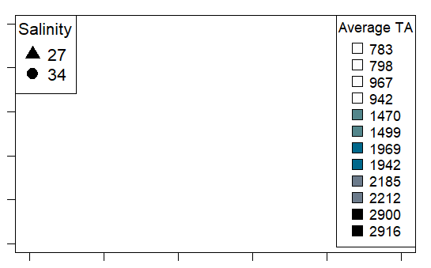

**A**

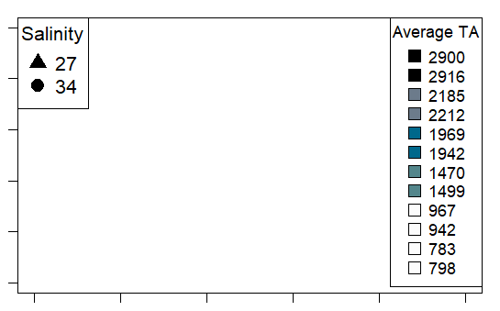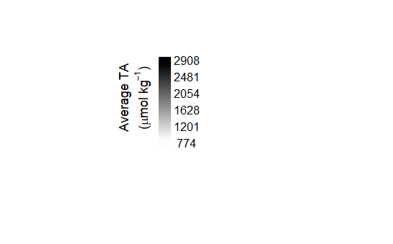

Before and after each water change during both experiments, we measured seawater temperature, salinity, pH, and dissolved oxygen concentration with a handheld multi-parameter sensor (YSI X). In X percent of pH measurements, we collected and analyzed discrete bottle samples for spectrophotometric determination of pH (calibrated on the same day with m-cresol dye standards, Easley and Byrne 2015), and used the latter data to translate pH data to the total scale. We also collected and immediately froze 250 ml seawater samples before and after each water change for later alkalinity determination. We quantified seawater TA in triplicate using a Metrohm 855 Titrosampler, correcting titration acid concentration daily with certified reference materials from the laboratory of Dr. Andrew Dickson (Scripps Institute of Oceanography). Finally, we used measurements of seawater TA (µmol kg-1) and pH (total scale) at specified salinities and temperatures to estimate the remaining seawater carbonate system parameters with the *seacarb* package in the software R (version 3.3.1). In our *seacarb* estimates, we used equilibrium constants from Lueker et al. 2000 (K1 and K2), Perez and Fraga 1987 (Kf), and Dickson 1990 (Ks). For simplicity, we refer to the seawater carbonate system in terms of TA, though additional carbonate system parameters vary in conjunction with shifts in alkalinity (Table S1), some of which may influence oyster growth separately from salinity and TA (cite).

**Chemical manipulation of seawater—** Seawater chemical conditions at the beginning of the two experiments and at each water change were established as follows. We first depleted seawater TA to negligible concentrations in large sumps (n = 4 sumps/water change) by adding hydrochloric acid (HCl) to drive the carbonate system reactions towards CO2, which then off-gassed over two days in conjunction with strong bubbling with air. We then mixed the TA-depleted seawater with distilled fresh water and premade solutions of NaHCO3 (sodium bicarbonate) and Na2CO3 (sodium carbonate) with HCl to adjust the carbonate system back to desired salinity and TA levels (Waldbusser et al. 2015, Ninokawa et al. in review).

**Statistical analysis—** All statistical tests were performed in R Studio (ver. 2022.07.02). We used smixed effects model (*nlme*, *lme4*) to explore how TA affects shell growth over the course of an exposure trajectory, within two discrete salinity levels, and as a function of initial size. We explored growth responses across time, focusing on two temporal periods: an early response window (days 0-18), and a later response window (days 18-36). The initial size corresponded to the projected surface area at the beginning of the time window under consideration. Total alkalinity and initial oyster size were treated as continuous, fixed effects, whereas salinity level (ambient versus low) and response window (early versus later) were included as categorical effects. We included oyster and experimental bin as random intercepts to account for the lack of independence associated with repeated sampling of the same oysters and in the likeliness that oysters from the same bin may respond more similarly, respectively. The effect of the first time window is demonstrated by the independent intercepts and slope estimates of the fixed effects. To test for an effect of the second time window on responses to TA and salinity, we included interaction terms between response window and TA or salinity level, separately. We used similar models to test the influence of TA, salinity, and initial oyster size on relative growth rate. The influence of the three predictors on shell thickness (shell mass per area, mg mm-2) and condition index (tissue mass per shell mass, mg mg-2) were also tested, and included culture vessel as a random intercept. We added a weighted variance term to models that failed the Breusch-Pagan test (*lmtest*) for residual heteroscedasticity, which specifies that the weight of each data point is equal the proportional variance across bins. Assumptions of normality were visually assessed with qqplots and histograms of model residuals. We employed backwards step-wise model selection to test the effect size of parameters found significant in the model, running ANOVA comparisons between a model with a full model, and one with the parameter omitted. The computed L-ratios, shown in Tables 1-4, indicate a proportional effect size relative to other predictors in the model, at a given p-value.

***Results—***

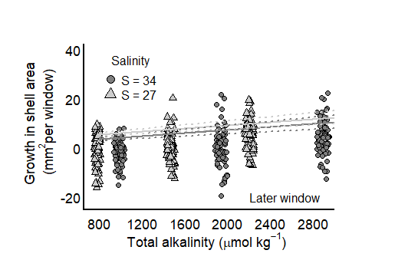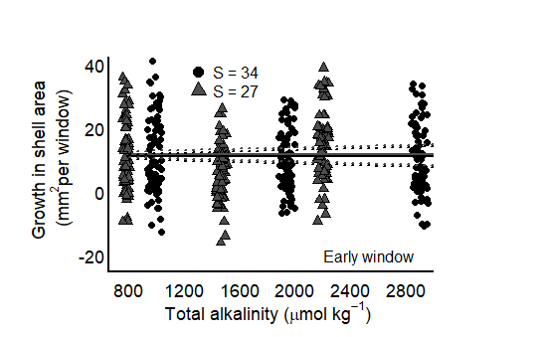

Fig. 3 Growth in shell area (unit) does not exhibit separate relationship with salinity (color) in neither the A) early (0-18 days) nor B) later (18-36 days) window in juvenile *C virginica* oysters. Model predicted intercepts and slopes (line) and SE borders (dashed line) were taken from a mixed-effects model, and therefore incorporate the effect of other model predictors (Table X).

**B**

**A**

**Growth in shell area as a function of time—** Growth in oyster shell area was higher during the early (0-18 d) response window than the later (19-36) response window (Fig. 3a). Although growth in shell area during the early response window did not vary with TA, this parameter had a positive effect on growth in shell area during the later response window (Table 1, Fig. 3A). The pattern during the later temporal window may indicate that TA is more important when oysters are calcifying less actively. In the early response window, there was a positive relationship between initial size and growth rate, indicating larger oysters exhibited higher rates of shell growth in any seawater condition, however, the relationship was reversed in the later window (Table 1, Fig 3B). The relationship between TA and oyster growth did not differ as a function of salinity treatment in either window (Fig. 4).

Fig. 4 Growth in shell area (unit) exhibits different relationships with size at the start of the period, between early (0-18 days) and later (18-36 days) exposure windows in juvenile *C. virginica* oysters. In the early window growth was higher in larger oysters (black points), where larger oysters exhibited lower growth in the later window (grey points). Intercept and slope model predictions (line) and SE borders (dashed lines) were taken from a mixed-effects model in Table X.

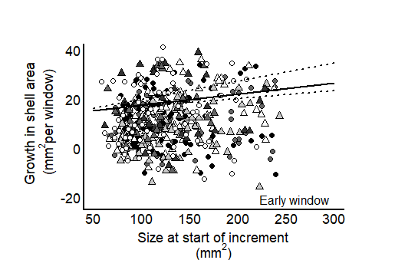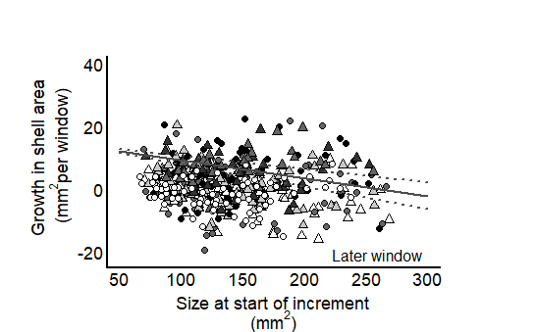

**B**

**A**

Fig. 5. Neither changes in total alkalinity (unit) nor salinity level (color) influence the relative growth in shell area (unit) of juvenile *C. virginica* oysters after 5 weeks of exposure to altered conditions. Intercept and slope model predictions (line) and SE borders (dashed lines) were taken from a mixed-effects model in Table X.

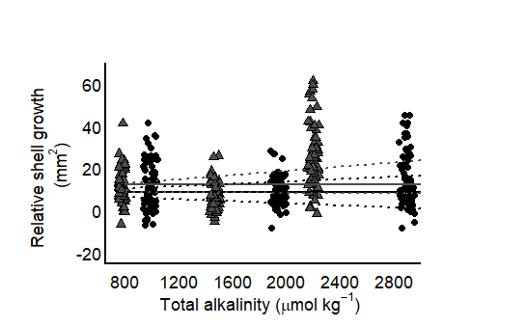

**Relative shell growth after 5 weeks—** Relative shell growth was uninfluenced by TA concentration, nor salinity after 5 weeks of exposure, but increased with the initial size, reflecting a similar pattern to shell growth in the early exposure window. Moreover, relative shell growth was robust to corrosive seawater conditions caused by low TA but did not elevate growth in higher TA conditions (Table 2). As our some of our treatments fell below the saturation state for calcium carbonate minerals, oyster shells in these treatments had an abiotic tendency to dissolve in seawater. Because we did not detect an effect of TA, this suggests that oysters were able to overcome consequences of an increased tendency to dissolve in seawater conditions. To maintain similar overall shell growth suggests oysters in corrosive seawater conditions may have upregulated biological calcification rates to off-set ‘low-TA driven’ shell dissolution. We speculate this stems from a well-fed environment but did not target the impact of food-availability in this study. We detected higher relative shell growth from oysters that were initially larger in size possibly due to the increased surface area available to calcify onto or the greater ability of larger oysters (with maintained tissue reserves) to calcify.

**Shell thickness & condition index—** Neither shell thickness nor condition index exhibited signs of trade-offs to shell growth in the range of tested TA and salinity, which due to the need to sacrifice animals to determine this quantity, was assessed only at the end of the 36-d experiment. However, oysters with larger initial shell areas tended to have a higher condition index. With regard to shell thickness, none of the factors of TA, salinity, and size exhibited effects. Average tissue mass greatly exceeded that of un-fed oysters held in lab seawater (ave. unfed = X vs fed = X) indicating an ability of all oysters to assimilate and store food as tissue mass, regardless of seawater treatment.

Fig. 6. Neither changes in total alkalinity (µmol kg-1) nor salinity level (color) influence A) shell thickness (mg mm2) or B) the condition index (mg mg2) of juvenile in *C. virginica* oysters. A lack of an effect of TA may suggest that trade-offs in other growth metrics, in order to maintain relative shell growth, did not occur.

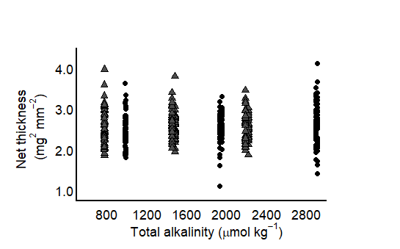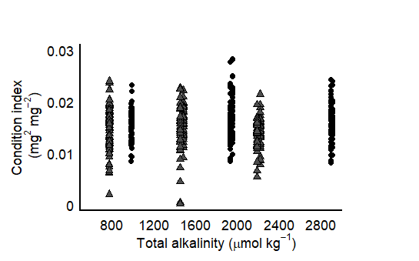

**B**

**A**

***Discussion—***

***Tables—***

Table 1. Results of mixed effects, linear model testing the effects of TA and initial size on *growth in shell area* (mm2) between two salinities, as a function of exposure window (early or later) in juvenile *Crassostrea virginica* oysters exposed to altered seawater conditions for 5 weeks. The difference in surface area was calculated relative to the size of the oyster at the beginning of the experimental window. L-Ratios and p-values were recorded during backward stepwise model selection and refer to the ANOVA test output between the full model and a model with the specified predictor omitted. L. Ratios were not computed for parameters found to be insignificant. Bolded values denote a significant effect, determined by alpha < 0.05. The final model: Incremental growth rate ~ size + categorical(salinity, 2 levels) + continuous(TA) + categorical(time period, 2 levels) + interaction (TA: time period) + interaction (S + time period) + RI(bin), accounted for ~ 30% of the variation.

|  |  |  |  |  |  |  |
| --- | --- | --- | --- | --- | --- | --- |
| **Fixed Effects**  marg. r2 = 0.30  cond. r2 = 0.30 | **Estimate** | **Std. Error** | **t-value** | **df** | **L. Ratio** | **p-value** |
| Intercept (ambient S) | 1.7609 | 0.2019 | 8.7220 | 446 | -- | **< 0.0001** |
| Low S | -0.0091 | 0.0576 | -0.1586 | 446 | -- | 0.8740 |
| Initial size | 0.0012 | 0.0004 | 2.7984 | 445 | 6.5126 | **0.0016** |
| TA (umol kg-1) | 1.3900e-05 | 4.0090e-05 | 0.3478 | 446 | -- | 0.7281 |
| Time period (ambient S) | -0.0653 | 0.0069 | -9.4658 | 445 | -- | **< 0.0001** |
| Interaction (TA: Time) | 0.0002 | 0.0001 | 3.5412 | 445 | 12.5400 | **0.0004** |
| Interaction (Low S: Time) | 0.1855 | 0.0814 | 2.2796 | 445 | 5.1965 | **0.0229** |
| **Random Effects** | **Intercept** | **Residual** |  |  | **L. Ratio** | **p-value** |
| Individual | 2.1804e-05 | 0.5762 |  |  | 6.3379e-07 | 0.9994 |
| Bin | Add | Add |  |  | Add | add |

Table 2. Results of mixed effects, linear model testing the effects of TA, salinity (categorical), and initial size on net shell growth rates (mm2 d-1) in juvenile *Crassostrea virginica* oysters. The difference in surface area was calculated as the difference between starting and ending shell size. L-Ratios and p-values were recorded during backward stepwise model selection and refer to the ANOVA test output between the full model and a model with the specified predictor omitted. Bolded values denote a significant effect, determined by alpha < 0.05. The final model: Net shell growth rate ~ size + categorical(salinity, 2 levels) + continuous(TA) + RI(bin), accounted for ~ X% of the variation.

|  |  |  |  |  |  |  |
| --- | --- | --- | --- | --- | --- | --- |
| **Fixed Effects**  marg. r2 = 0.16  cond. r2 = 0.52 | **Estimate** | **Std. Error** | **t-value** | **df** | **L. Ratio** | **p-value** |
| Intercept (ambient S) | -0.0743 | 0.1611 | -0.4615 | 436 |  | 0.6447 |
| Low S | 0.0743 | 0.1060 | 0.7009 | 9 |  | 0.5011 |
| Initial size (mm2) | 0.0020 | 0.0002 | 8.9071 | 436 |  | **< 0.0001** |
| TA | 0.0001 | 0.0001 | 1.4194 | 9 |  | 0.1895 |
| **Random Effects** | **Intercept** | **Residual** |  |  | **L. Ratio** | **p-value** |
| bin | 0.1681 | 0.1956 |  |  | 95.48962 | < 0.0001 |

Table 3. Results of mixed effects, linear model testing the effects of TA, salinity (categorical), and initial size on shell thickness (mg mm2) in juvenile *Crassostrea virginica* oysters. L-Ratios and p-values were recorded during backward stepwise model selection and refer to the ANOVA test output between the full model and a model with the specified predictor omitted. Bolded values denote a significant effect, determined by alpha < 0.05. The final model: Net shell thickness ~ initial size + categorical(salinity, 2 levels) + continuous(TA) + RI(bin), accounted for ~ X% of the variation.

|  |  |  |  |  |  |  |
| --- | --- | --- | --- | --- | --- | --- |
| **Fixed Effects**  marg. r2 = 0.01  cond. r2 = 0.01 | **Estimate** | **Std. Error** | **t-value** | **df** | **L. Ratio** | **p-value** |
| Intercept (ambient S) | 2.4040 | 0.0803 | 29.9037 | 436 | -- | **< 0.0001** |
| Low S | 0.0355 | 0.0394 | 0.9002 | 9 | -- | 0.3915 |
| Initial size (mm2) | 0.0006 | 0.0004 | 1.3511 | 436 | -- | 0.1774 |
| TA | 4.4500e-05 | 2.7460e-05 | 1.6220 | 9 | -- | 0.1392 |
| **Random Effects** | **Intercept** | **Residual** |  |  | **L. Ratio** | **p-value** |
| bin | 0.01 | 0.01 |  |  | 0.0130 | 0.9091 |

Table 4. Results of mixed effects, linear model testing the effects of TA, salinity (categorical), and initial size on condition index (mg mg-2) in juvenile *Crassostrea virginica* oysters. L-Ratios and p-values were recorded during backward stepwise model selection and refer to the ANOVA test output between the full model and a model with the specified predictor omitted. Bolded values denote a significant effect, determined by alpha < 0.05. The final model: Condition index ~ size + categorical(salinity, 2 levels) + continuous(TA) + RI(bin), accounted for ~ X% of the variation.

|  |  |  |  |  |  |  |
| --- | --- | --- | --- | --- | --- | --- |
| **Fixed Effects**  marg. r2 = 0.15  cond. r2 = 0.28 | **Estimate** | **Std. Error** | **t-value** | **df** | **L. Ratio** | **p-value** |
| Intercept (ambient S) | 0.0262 | 0.0042 | 6.1850 | 436 | -- | **< 0.0001** |
| Low S | -0.0035 | 0.0027 | -1.3166 | 9 | -- | 0.2205 |
| Initial size (mm2) | 0.0001 | 1.1252e-05 | 8.5433 | 436 | 69.7660 | **< 0.0001** |
| TA | 1.3980e-05 | 1.8430e-06 | 0.7583 | 9 | -- | 0.4677 |
| **Random Effects** | **Intercept** | **Residual** |  |  | **L. Ratio** | **p-value** |
| bin |  |  |  |  | 33.7828 | **< 0.0001** |